Graphing Exponential & Logarithmic Functions
~ Unit 12 Self-Pacing Guide ~
Check When Complete | Whole Class Lesson - L |  |  |  |  |  |  | Thurs  2/27
 | Class Lesson – “The Exponential Family”
Total/20 | Tasks | Poster Problems | Quick Notes | CYU #1 |  | CYU #2
 | Completed?
Check When Complete | Lesson 12.1 ~ Graphing Exponential Equations |  |  |  |  |  |  | Fri  2/28
 | Watch video & take notes (CraycraftsMathCrew.com)
 | Independent Practice: “12.1 – Graphing Exponential Equations” (DeltaMath)
 | Mastery Check (In Class)
Check When Complete | Whole Class Lesson - M |  |  |  |  |  |  | Mon  3/3
 | Class Lesson – “Exponential Match-Up”
Total/20 | Tasks | Poster Problems | Quick Notes | CYU #1 | CYU #2 |  | CYU #3
 | Completed? |  |  |  |  |  | Skip #4!
Check When Complete | Lesson 12.2 ~ Transformations of Exponential Functions |  |  |  |  |  |  | Tues 3/4  –  Wed 3/5
 | Watch video & take notes (CraycraftsMathCrew.com)
 | Independent Practice: “12.2 – Transformations of Exponential Functions” (DeltaMath)
 | Mastery Check (In Class)
Check When Complete | Whole Class Lesson - N |  |  |  |  |  |  | Thurs  3/6
 | Class Lesson – “Graphs of Logs”
Total/20 | Tasks | Poster Problems | Quick Notes | CYU #1a |  | CYU #1b
 | Completed?
Check When Complete | Whole Class Lesson - O |  |  |  |  |  |  | Fri  3/7
 | Class Lesson – “Lumberjack Graphs”
Total/20 | Tasks | Poster Problems | Quick Notes | CYU #1 | CYU #2 |  | CYU #3
 | Completed?
Check When Complete | Lesson 12.3 ~ Graphing Logarithmic Functions |  |  |  |  |  |  | Mon 3/10
 | Watch video & take notes (CraycraftsMathCrew.com)
 | Independent Practice: “12.3 – Graphing Logarithmic Functions” (DeltaMath)
 | Mastery Check (In Class)
Check When Complete | Unit Mastery Check |  |  |  |  |  |  | Tues 3/11 – Thurs 3/13
 | Tues, 3/11: Independent Practice (finishing Deltas & MathXL) & Catch-up on 12.1 – 12.3 Mastery Checks
 | Wed, 3/12: Graphing Exponentials & Logs – DFA 12 & work on Re-Focus (MathXL)
 | Thurs, 3/13: Graphing Exponentials & Logs – DFA 12 RETAKE

~ Unit 12 At A Glance ~
Complete the “I am Ready” problems for each lesson below.
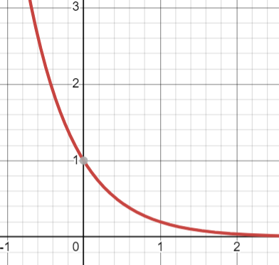
12.1
For the graph to the left, identify each of the following:
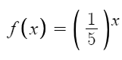
Domain: ________________
Range: ________________
End Behavior: ________________
y-intercept: ________________
Asymptote: ________________
Is the function/graph exponential growth or decay? Explain how you know based on the graph and the equation.
12.2

For the following function, describe its transformation from its parent function (without graphing it first!). How do you know?
$$f\left(x\right)=-5{\left(\frac{1}{3}\right)}^{x-4}-2$$

Parent function: ______________ How do you know? ______________
Horizontal shift: ______________ How do you know? ______________
Vertical shift: ______________ How do you know? ______________
Any reflections, stretches, and/or compressions? How do you know?

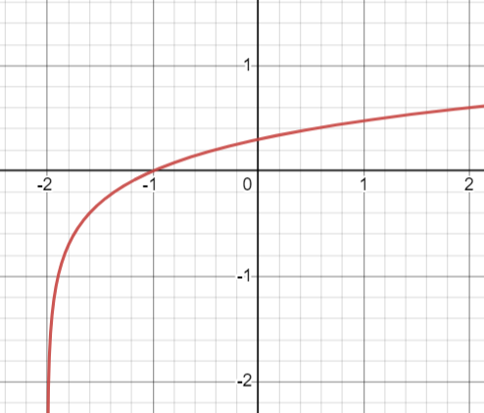
12.3
For the graph to the left, identify each of the following:

Domain: ________________
Range: ________________
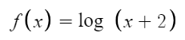
End Behavior: ________________
x-intercept: ________________
Asymptote: ________________
What is the relationship between a logarithmic function and an exponential function? How is this relationship represented graphically?

